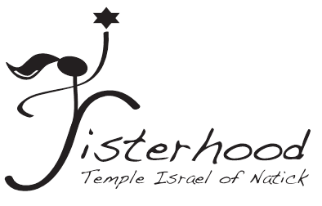
It’s Time to Join Sisterhood!
We are still here for you!

Sisterhood does so much!
Sisterhood continues to sponsor many wonderful activities throughout the year
including-Paid Up Supper, Donor Dinner, Sisterhood Shabbat, Book Discussion Groups,
Guest Speakers, Entertainment, Social Action activities…and so much more!

With your paid dues, we are able to…
- Provide financial support to the Synagogue, Religious School, Nursery School, and Shabbat Babysitting
- Sponsor and support Kiddushim and Holiday Events
- Provide subsidies and scholarships for Youth Conventions and Israel Programs
- Present gifts to new babies and B’nei Mitzvah

You must be a Sisterhood Member to be
on the Leagram list so please join or renew soon!
(Our extensive Leagram program enables members of our community to support each other by acknowledging simchot, and offering comfort during times of illness or loss)

- - - - - - - - - - - - - - - - - - - - - - - - - - - - - - - - - - - - - - - - - - - - - - - - - - - - - - - - - - - - - - - - - - - - - - - - - - - - - - - - - - - - - - - - - - - -
Please send your Sisterhood Dues with your check payable to:
Sisterhood of Temple Israel
Please mail this form and check to:
Rachelle Rea 25 Fox Hill Drive Natick, MA 01760
Please check a Dues Category: ___ Quadruple Chai ($72) ___Triple Chai ($54)
___ Double Chai and a half ($45) ___Member ($36)

___If you are already a Lifetime Sisterhood Member ($15 voluntary donation)
Thank you for your contribution to offset fees for Women’s League.
___New Temple Members receive complimentary first year membership.

Name: ____________________________________________________________________________________________
Address:___________________________________________________________________________________________
Telephone:__________________________________________ E-mail_________________________________________

